Instruction to the Lexical Program

Open the “InputCodes.txt”

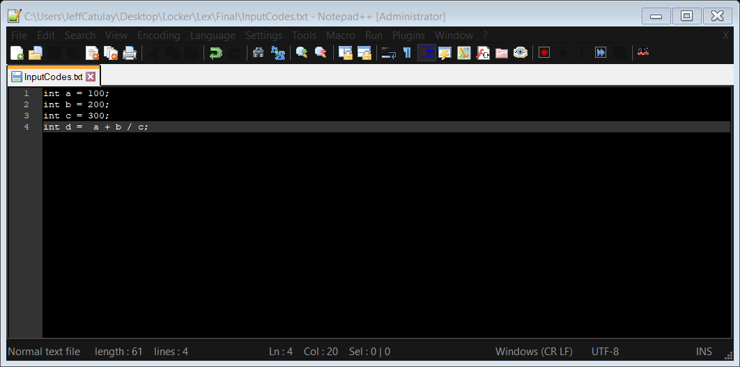Input sample code in the InputCodes.txt

Then run the “RunLexicalAnalyzer.exe”

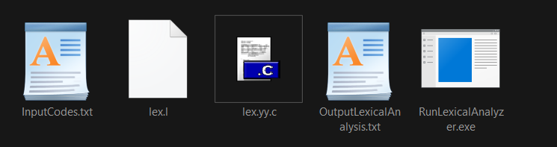

Open the “OuputLexicalAnalysis.txt”

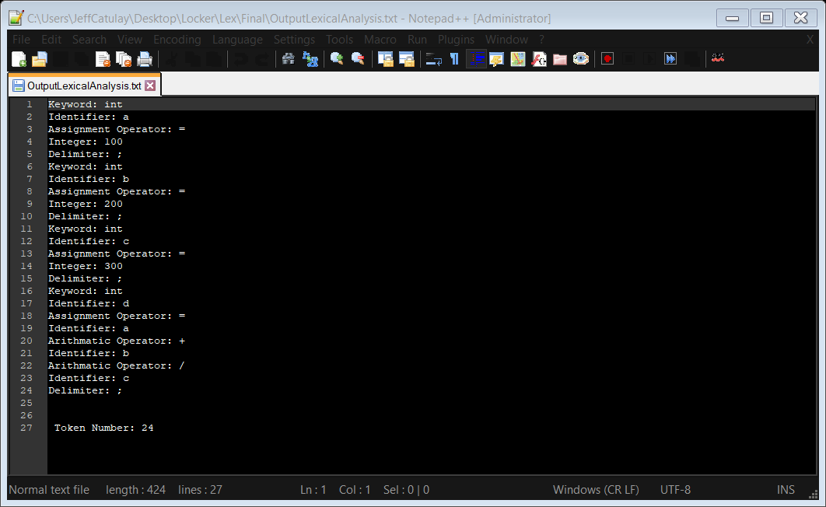

Codes:

%{

int total =0 ;

%}

%option noyywrap

%%

#.* {total++; fprintf(yyout,"Pre-processor directive: %s\n",yytext);}

[''|,|;(|)|{|}|.|_] {total++; fprintf(yyout,"Delimiter: %s\n",yytext);}

[[]] {total++; fprintf(yyout,"Delimiter: %s\n",yytext);}

"#"|"@"|"$"|"^"|"%"|"^"|"&" {total++; fprintf(yyout,"Special Characters: %s\n",yytext);}

"["|"]" {total++; fprintf(yyout,"Delimiter: %s\n",yytext);}

"=" {total++; fprintf(yyout,"Assignment Operator: %s\n",yytext);}

"+"|"-"|"*"|"/" {total++; fprintf(yyout,"Arithmatic Operator: %s\n",yytext);}

"and"|"or"|"not"|"nand"|"xor"|"nor"|"xnor" {total++; fprintf(yyout,"Logical Operators: %s\n",yytext);}

"<="|">="|"++"|"!="|"=="|"<"|">" {total++; fprintf(yyout,"Relational Operator: %s\n",yytext);}

("int")|("if")|("else")|("while")|("do")|("break")|("continue")|("double")|("float")|("return")|("EOF") {total++; fprintf(yyout,"Keyword: %s\n",yytext);}

("return")|("char")|("case")|("sizeof")|("long")|("short")|("typedef")|("switch")|("unsigned")|("void")|("static")|("struct")|("goto") {total++;fprintf(yyout,"Keyword:%s\n",yytext);}

[a-zA-Z_][a-zA-Z0-9_]*\( {total++; fprintf(yyout,"Function: %s\n",yytext);}

[a-zA-Z_][a-zA-Z0-9_]* {total++; fprintf(yyout,"Identifier: %s\n",yytext);}

[0-9]*"."[0-9]+ {total++;fprintf(yyout,"TFraction : %s\n", yytext);}

[-][0-9]*"."[0-9]+ {total++;fprintf(yyout,"Negative Fraction : %s\n", yytext);}

[0-9]+ {total++; fprintf(yyout,"Integer: %s\n",yytext);}

"-"[0-9]+ {total++; fprintf(yyout,"Negative Integer: %s\n",yytext);}

["]([^"\\\n]|\\.|\\\n)*["] {total++; fprintf(yyout,"String:%s\n",yytext);}

"//".*" "* {total++;fprintf(yyout,"Single line Commments: %s\n",yytext);}

\/\*(.*\n)*.*\*\/ {total++;fprintf(yyout,"Multi line Comments: %s\n",yytext);}

. {fprintf(yyout,"",yytext);}

[\t\n]+

%%

main()

{

extern FILE *yyin, *yyout;

yyin = fopen("InputCodes.txt", "r");

yyout = fopen("OutputLexicalAnalysis.txt", "w");

yylex();

fprintf(yyout,"\n\n Token Number: %d",total);

return 0;

}